**Experiment No. 12**

**Aim: Implement a web application using Django Framework and understand CRUD functionality.**

**Code:**

**urls.py (project)**

from django.contrib import admin

from django.urls import path,include

from api import views

urlpatterns = [

    path('studentAPI/',views.StudentListCreate.as_view()),

  path('studentAPI/<int:pk>',views.StudentRetrieveUpdateDestroy.as_view())

]

**Models.py**

from django.db import models

class Student(models.Model):

    name = models.CharField(max_length=100)

    roll = models.IntegerField()

    city = models.CharField(max_length=100)

**Serializer.py**

from rest_framework import serializers

from .models import Student

class StudentSerializer(serializers.ModelSerializer):

    class Meta:

        model = Student

        fields = '__all__'

def validate_name(self,value):

        if (all(chr.isalpha() or chr.isspace() for chr in value)):

            return value

        raise serializers.ValidationError(

            "Name must have alphabets only")

**Views.py**

from .models import Student

from .serializers import StudentSerializer

from rest_framework.generics import ListCreateAPIView,RetrieveUpdateDestroyAPIView

class StudentListCreate(ListCreateAPIView):

    queryset = Student.objects.all()

    serializer_class = StudentSerializer

class StudentRetrieveUpdateDestroy(RetrieveUpdateDestroyAPIView):

    queryset = Student.objects.all()

    serializer_class = StudentSerializer

**Output:**

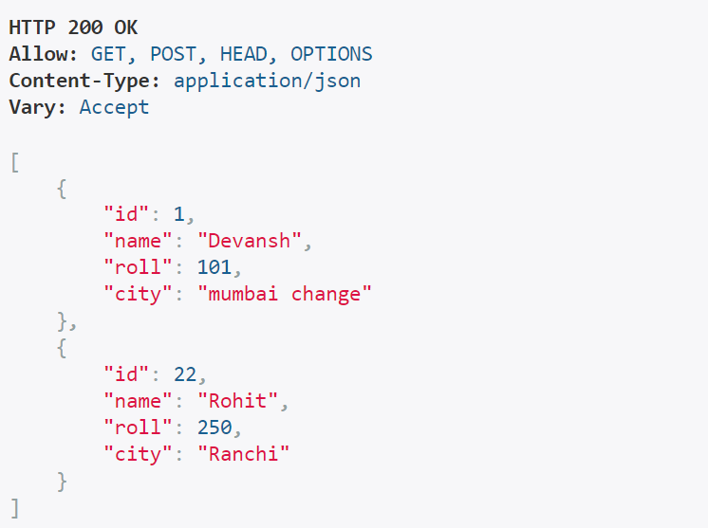**Get Data**

**Post Data**



**New data after inserting**

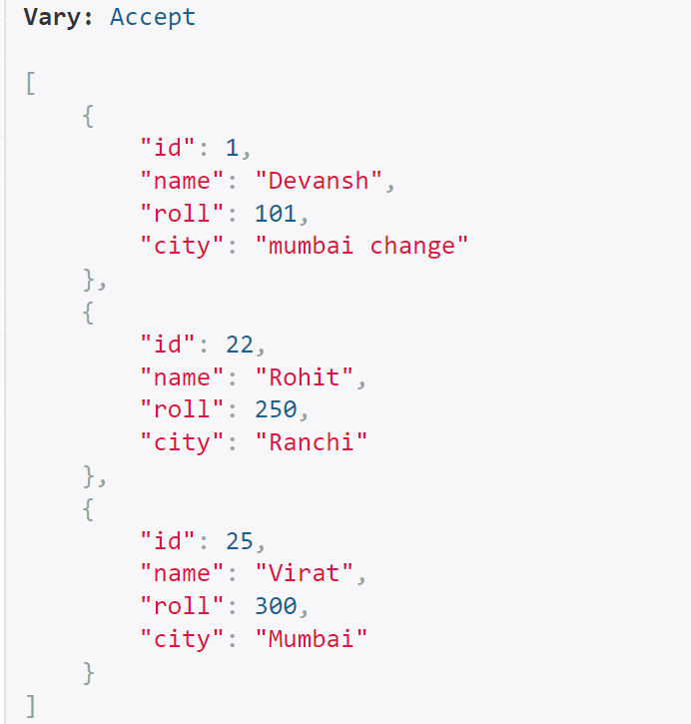

**Updating Existing Data**

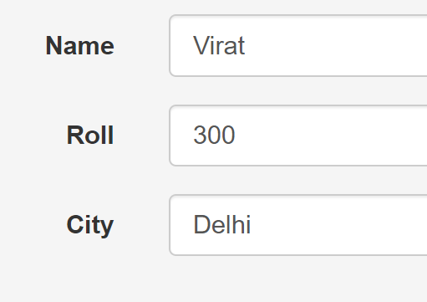

**New data after updation**

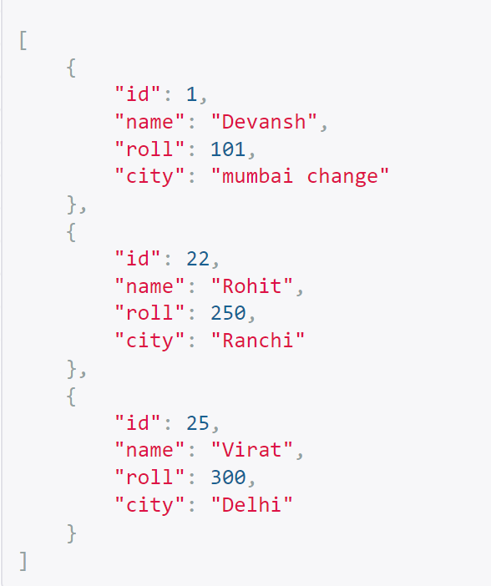

**Deleting data with ID 25**

